CITY OF LOGAN
POLICE DEPARTMENT

2023 ANNUAL REPORT

Jerry Mellinger, Chief of Police

INTRODUCTION

On behalf of the men and women of the Logan Police Department, I am pleased to present the 2023 annual report. Through the narrative and statistics within this report, I hope to provide the residents of Logan further transparency between the police department and the community which we serve.

I am exceedingly proud of my sworn officers and civilian staff who bring to life this police department. Their hard work and diligence provide stability amongst the challenges of the always fluctuating criminal justice environment. We understand that building and maintaining strong relationships within our community is essential to achieving the critical relations needed to better serve and protect the City of Logan. For this reason, in conjunction with our community outreach initiatives, we will continue forward with our mission of preservation of life, reduction of fear and crime, and the protection of persons and property within our community.

I am truly honored to lead this organization. As we look ahead to the challenges of 2024, it is through mutual respect and support that allows us to succeed and grow as a community. We look forward to gaining new community partnerships and nurturing existing ones as we move forward in 2024. The Logan Police Department remains committed to keeping our community a safe place to live, work, and raise a family and we will do so through effective policing and community partnerships.

DEPARTMENT MISSION

The mission of the Logan Police Department is to create a safer Logan by reducing crime, ensuring the safety of our citizens, and building trust in partnership with our community.

DEPARTMENT MOTTO

The Department’s motto is to “Serve and Protect”. Personnel pride themselves on the personal touch service offered to the community. The department believes in its philosophies of grass roots policing and strive to be proactive rather than reactive. It is for this, and other reasons, that the community continues to strongly support its police department.

COMMUNITY RELATIONS
The cornerstone of the organization’s philosophy is its community oriented, grass roots, customer-based service style policing effort. Employees strive to fulfill this goal by providing the citizens of Logan with a full range of police services 24 hours a day, 7 days a week, and 365 days a year. Both the Department and its employees are committed to providing exceptional service and maintaining an excellent “quality of life” environment for the public. Throughout the year, officers and staff can be seen at local festivals, motorcycle runs, and many other local events.

2023 SIGNIFICANT EVENTS

- The Police Department participated in many community outreach programs (see Community Outreach Initiatives section for a full list).
- Continued the Department wide Computer Aided Dispatch system.
- Celebrated the 100th Anniversary of the Logan Police Department.
- Continued the Tesla fleet program, saving nearly $5500 in fuel costs.
- All Officers completed the State mandated twenty-four hours of Continuing Professional Training.
- Maintained certification through the Ohio Collaborative Community- Police Advisory Board.
- Lieutenant Mike Walton retired after completing 33 years of service, and Patrolman Scott Mingus retired after completing 25 years of service to the City of Logan.
- Promoted Patrolman Shawn Woodgeard to the rank of Lieutenant.

BUDGET

The Logan Police Department’s annual revised budget appropriation for 2023 was $2,752,816.00. This was funded almost exclusively by the City’s General Fund, which accounted for $2,467,807.00 of the overall budget. The remaining $285,009.00 was funded through Capital Improvements.

GRANTS RECEIVED

- Federal Ballistic Vest Program (BVP) - $3,000.00

- OHLEG Body Armor Grant - $3,024.59

- ARPA Wellness Grant - $10,000.00

STAFFING and ASSIGNMENTS

The following spreadsheet reflects staffing for the calendar year.

Position Police Department | Authorized Strength | January | February | March | April | May | June | July | August | September | October | November | December
Chief of Police | 1 | 1 | 1 | 1 | 1 | 1 | 1 | 1 | 1 | 1 | 1 | 1 | 1
Captain | 1 | 1 | 1 | 1 | 1 | 1 | 1 | 1 | 1 | 1 | 1 | 1 | 1
Lieutenant | 3 | 3 | 3 | 3 | 3 | 3 | 3 | 3 | 3 | 3 | 3 | 3 | 3
Detective | 2 | 2 | 2 | 2 | 2 | 2 | 2 | 2 | 2 | 2 | 2 | 2 | 2
Patrolman | 9 | 9 | 9 | 9 | 9 | 9 | 9 | 9 | 9 | 9 | 9 | 7 | 7
SRO | 3 | 3 | 3 | 3 | 3 | 3 | 2 | 2 | 3 | 3 | 3 | 3 | 3
Full Time Dispatcher* | 4 | 3 | 3 | 3 | 3 | 3 | 4 | 4 | 4 | 4 | 4 | 3 | 3
Part Time Dispatcher | 2 | 0 | 0 | 0 | 0 | 0 | 0 | 0 | 0 | 0 | 0 | 1 | 1
Records Clerk | 1 | 1 | 1 | 1 | 1 | 1 | 1 | 1 | 1 | 1 | 1 | 1 | 1
Absent Positions |  | 2 | 2 | 2 | 2 | 2 | 2 | 2 | 2 | 2 | 2 | 4 | 4

CRIME STATISTICS

Included within this report are several tables and figures analyzing Calls for Service (CFS) data, National Incident Based Reporting System (NIBRS) data and self-initiated traffic top data for our agency. Tables 1 and 2 found in this section of the report show the last four-five years of data on an annual basis and should be used for comparison. Figures 1 through 4 found in this section of the report are specific to 2023 data only.

Figures 5 through 7 found in this section of the report are specific to 2023 self-initiated traffic stop data.

CFS DATA – Table 1 is a detailed listing of all CFS to the Logan Police Department. This list reflects the CFS as they were reported from the caller to the Dispatcher. This table does not reflect changes made to the original CFS due to a status change such as unfounded or a change to a more accurate call type.

Table 1: CFS Data.

Type of Call for Service | 2019 | 2020 | 2021 | 2022 | 2023
911 Hang ups | 73 | 62 | 35 | 54 | 51
Accident/Property only | 221 | 184 | 216 | 182 | 194
Accident/Injury | 35 | 25 | 29 | 4 | 20
Accident-Hit/Skip property | 70 | 72 | 71 | 58 | 56
Accident-Hit/Skip injury | 0 | 1 | 2 | 3 | 0
Alarm Calls | 203 | 192 | 215 | 209 | 175
Animal Complaint | 58 | 92 | 92 | 138 | 164
Assault | 76 | 28 | 53 | 50 | 35
Assist other unit | 290 | 248 | 237 | 231 | 260
Bad Check/forgery/Identity Fraud | 9 | 6 | 11 | 25 | 41
Burglary | 97 | 106 | 67 | 65 | 40
Civil Complaints | 92 | 73 | 45 | 39 | 44
Criminal Damaging | 38 | 18 | 18 | 22 | 15
Criminal Mischief | 33 | 20 | 21 | 19 | 6
Criminal Trespass | 100 | 181 | 76 | 85 | 81
Code Enforcement Calls³ |  |  |  | 309 | 445
Disorderly Conduct | 75 | 95 | 87 | 102 | 121
Disabled/Abandoned Vehicles | 95 | 65 | 70 | 70 | 99
DOA | 10 | 7 | 10 | 11 | 5
Dog Bite | 5 | 8 | 9 | 4 | 7
Domestic/Disturbances | 225 | 254 | 203 | 125 | 115
Drug Complaints | 105 | 69 | 75 | 68 | 64
Drunk | 90 | 51 | 36 | 31 | 21
Emergency Squad needed | 0 | 0 | 1 | 16 | 3
Escorts/Parades | 75 | 62 | 43 | 50 | 52
Explosions | 1 | 1 | 1 | 2 | 0
Fight | 96 | 68 | 61 | 51 | 37
Fire Calls | 41 | 21 | 13 | 17 | 13
Follow-ups | 15 | 23 | 6 | 1 | 25
Found Property | 107 | 66 | 73 | 88 | 88
Homicides | 0 | 1 | 0 | 0 | 0
Investigative Complaints | 1083 | 1289 | 872 | 723 | 789
Juvenile Complaints | 162 | 110 | 112 | 154 | 134
Theft | 520 | 411 | 347 | 388 | 328
Mental | 67 | 45 | 71 | 89 | 54
Missing Persons/Returned | 29 | 40 | 39 | 31 | 17
Motorist Assists | 396 | 386 | 325 | 389 | 290
Person with a gun/knife | 20 | 14 | 6 | 15 | 13
Nature Unknown | 64 | 61 | 45 | 27 | 14
Neighbor Complaints | 71 | 168 | 111 | 81 | 77
Prowler | 56 | 51 | 10 | 5 | 3
Rape | 6 | 6 | 8 | 4 | 12
Other Sexual Offenses | 29 | 20 | 16 | 34 | 21
Road Blocked | 8 | 6 | 1 | 15 | 8
Robbery | 5 | 4 | 1 | 2 | 2
Shooting/Shots fired | 10 | 5 | 7 | 7 | 4
Stabbing | 4 | 0 | 0 | 1 | 0
Stolen Vehicle | 38 | 60 | 34 | 22 | 29
Recovered Stolen Vehicle | 15 | 19 | 14 | 3 | 10
Special Detail | 5 | 3 | 3 | 7 | 23
Suicide/Suicidal | 67 | 42 | 36 | 31 | 71
Suspicious Person/Vehicle | 536 | 442 | 307 | 352 | 308
Unknown | 57 | 41 | 29 | 27 | 65
Vandalism | 35 | 23 | 20 | 18 | 27
Threats/Harassment | 142 | 123 | 102 | 138 | 130
Open Door | 29 | 19 | 13 | 23 | 12
Traffic Offense | 66 | 27 | 18 | 30 | 49
Traffic Stops¹ | 970 | 773 | 801 | 503 | 367
Warrant/Civil Process | 203 | 185 | 160 | 147 | 132
Welfare Checks | 239 | 209 | 187 | 255 | 214
All other misc. call types² | 44 | 83 | 225 | 182 | 49
Total | 7311 | 6764 | 5796 | 5832 | 5529

Table 1: Number of calls for service broken into different Types.

1 - Call type started late 2017. Most of the previous call types for this will be under Traffic Offenses.
2 - To include Notes for record, prisoner transports, etc.
3 - Call type started in 2021

REPORT DATA

Table 2 is an abbreviated listing of actual offenses. This table does not reflect all offenses for 2023, only those reports that are typically considered of general interest to the public.

Table 2: Report Data.

Offenses | 2019 | 2020 | 2021 | 2022 | 2023
Assault: all | 98 | 52 | 55 | 57 | 44
Breaking and entering | 49 | 43 | 13 | 10 | 14
Burglary | 45 | 33 | 12 | 13 | 13
Criminal Damaging/Vandalism | 28 | 18 | 45 | 7 | 11
Criminal Mischief | 123 | 103 | 39 | 61 | 40
Criminal Trespass | 94 | 122 | 43 | 60 | 61
Disorderly Conduct | 218 | 182 | 78 | 98 | 82
Drug Offenses | 105 | 101 | 16 | 45 | 40
Drug Para/Instruments | 110 | 100 | 49 | 39 | 40
Domestic/Disturbances | 64 | 64 | 38 | 45 | 37
Violating a Protection Order | 32 | 33 | 17 | 14 | 24
Harassment | 17 | 14 | 4 | 11 | 8
Homicides | 0 | 0 | 0 | 0 | 0
Menacing | 56 | 39 | 13 | 29 | 19
Motor Vehicle Theft | 11 | 8 | 4 | 17 | 14
OVI | 19 | 18 | 10 | 21 | 15
Rape | 14 | 7 | 3 | 13 | 14
Other Sex Crimes | 32 | 7 | 8 | 14 | 14
Robbery | 6 | 4 | 1 | 0 | 0
Theft | 444 | 359 | 137 | 241 | 209
Totals | 1565 | 1307 | 585 | 795 | 699

Figure 1: Number of CFS by days of the week.

Figure 1 Illustrates that CFS volume rises as the week progresses. This data reflects CFS from January 1, 2023, through December 31, 2023.

Figure 2: Number of Offense Reports by days of the week.

Figure 2 Illustrates that offense reports volume rises as the week progresses. This data reflects offense reports from January 1, 2023, through December 31, 2023.

Figure 3: City of Logan Geocode map.

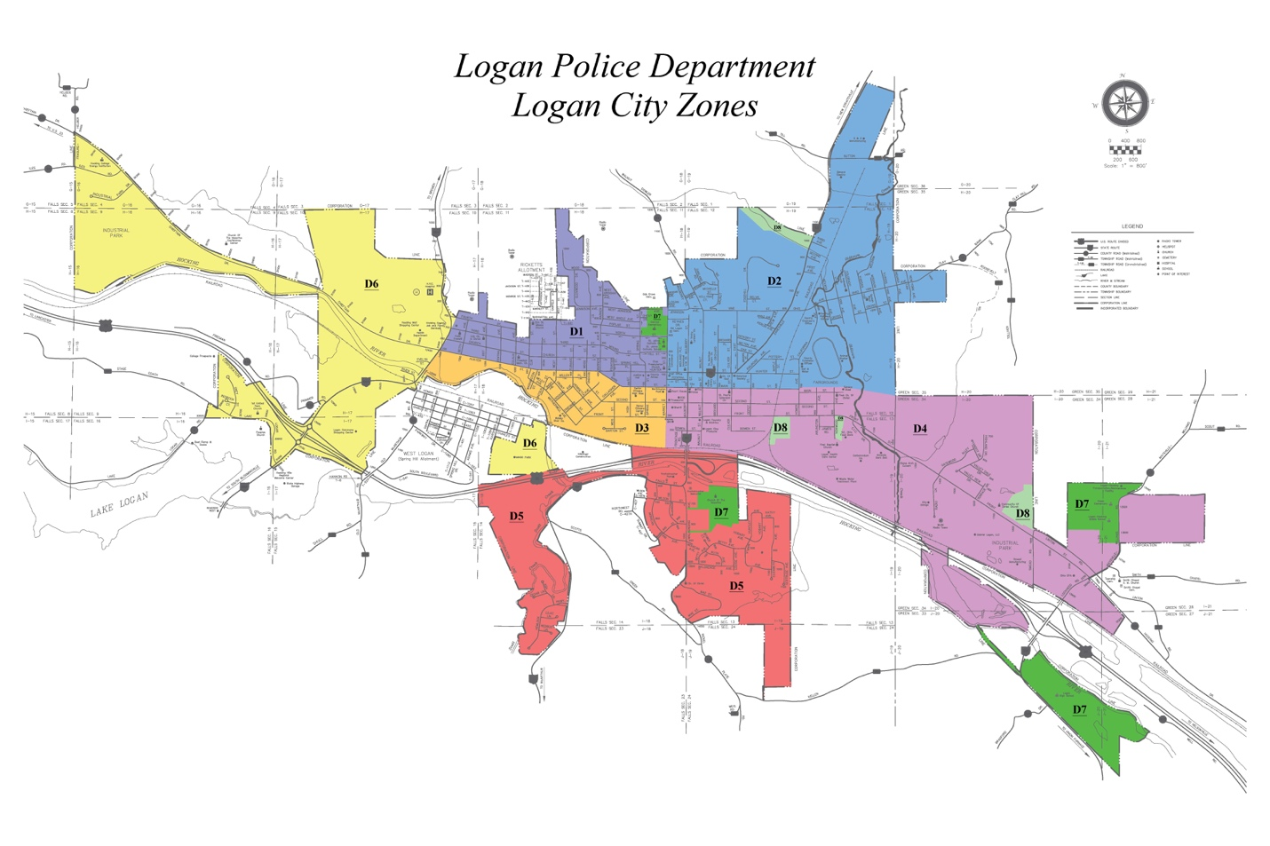

Figure 3 illustrates the districts of the City of Logan broken down into Geocodes for CFS reporting purposes.

Figure 4: Number of CFS per Geocode.

Figure 4 Illustrates the CFS per Geocode district. “Unknown” is over reported due to the unknown nature of the Geocode when a CFS is taken.

Note: HVCH is Hocking Valley Community Hospital.

Figure 5: Self-initiated traffic stops by race.

Figure 6: Total self-initiated traffic stops data chart.

2023 Traffic Stats
Total Stops | 339
Total Stops with Citations | 57
Total Stops with Warnings | 280
Stops with no data | 2
Total Males | 207
Total Female | 127
 |  | Percentages
White | 324 | 95.58
Black | 9 | 2.65
Hispanic | 0 | 0.00
Asian | 0 | 0.00
Other | 1 | 0.29
Unknown | 5 | 1.47

Figure 5 and Figure 6 illustrate the number of self-initiated traffic stops by race and the percentage of total self-initiated traffic stops that number represents.
Figure 7: Self-initiated traffic stop, citations versus warnings.

Figure 7 illustrates the number of self-initiated traffic stops, citations versus warnings as they relate to race and gender.

COMMUNITY OUTREACH INITIATIVES

SHOP WITH A COP:

Taking place during the Christmas season, this unique experience provides for children in need throughout the community while creating positive relationships with law enforcement. Annually, uniformed first responders from various local and state offices, healthcare workers, and veterans volunteer their time to shop with the children at the local Walmart. In 2023, the Shop with a Cop program assisted 440 families throughout our community with a total contribution of just over $40,000.

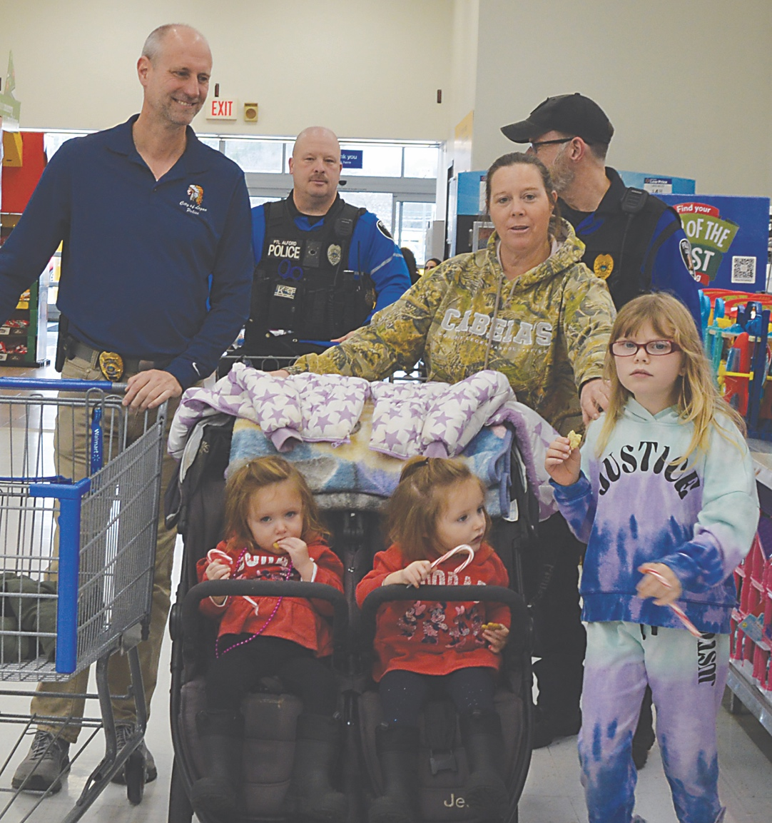

K9 OFFICER DEMONSTRATIONS:

Throughout the year, K9’s Rambo and Anni travel throughout the community providing demonstrations to local charitable organizations as well as to our local schools. Additionally, the Logan Police Department K9’s present demonstrations to members of Tri-County Technical High School’s criminal justice program and participates in their annual job fair.

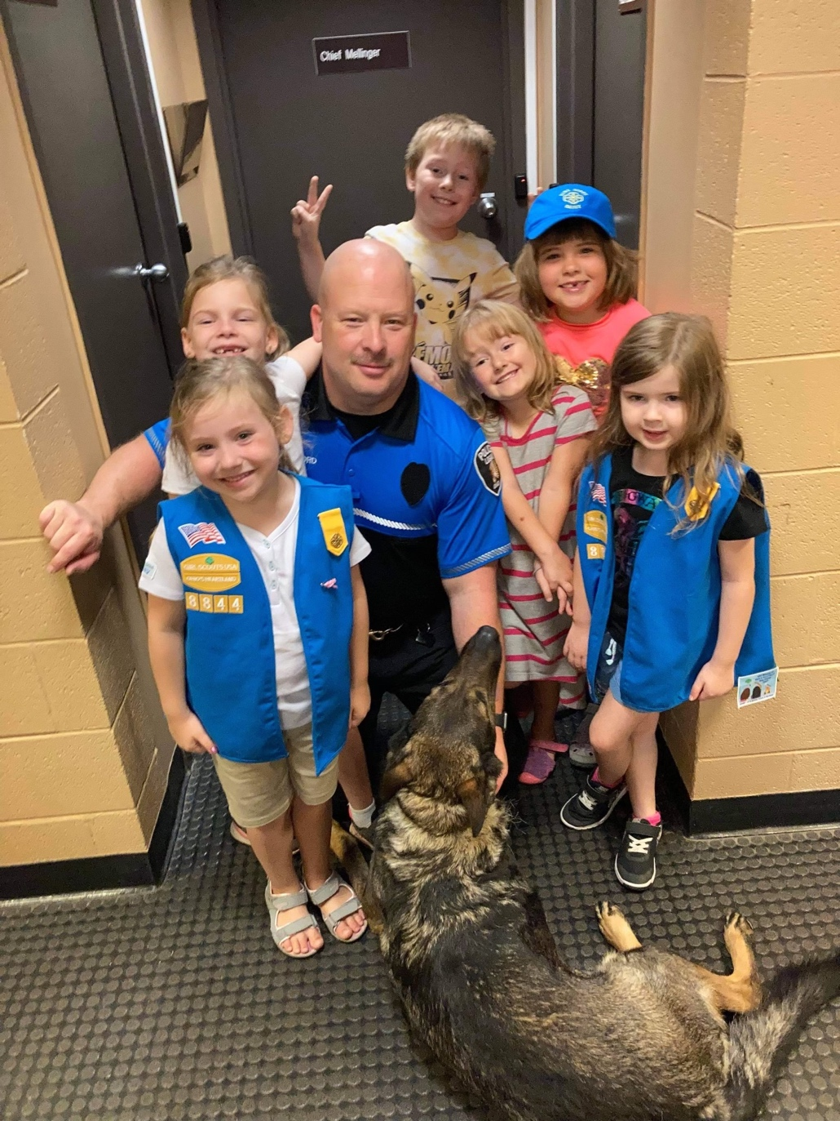

SAVE CHRISTMAS FROM THE GRINCH:

A local realty business in Logan, initiated a program this year, “Save Christmas from the Grinch”. The local business donated a Santa Mailbox in front of their storefront, where local children could send a letter to Santa, and it would be answered. The other part of the program involved the business posting on social media, the local newspaper, and radio stations about the “Grinch” being seen locally trying to steal the letters from the mailbox. The program culminated with an event in downtown Logan, where local children were given “Heart” stickers and when the “Grinch” arrived, Officers from the Logan Police Department arrested the Grinch, and the children placed the heart stickers on his costume. The Grinch was transported by the Logan PD officers in marked cruisers and then brought back a short time later to the event. When the Grinch emerged from the cruiser, officers advised that his heart grew while in jail thanks to the children, so they let him out. The Grinch then wished everyone a Merry Christmas and lead in the singing of Christmas Carols. Children were allowed to have pictures taken with the Grinch and the participating Officers after the event. Due to the popularity of the event, it’s scheduled to continue next year.

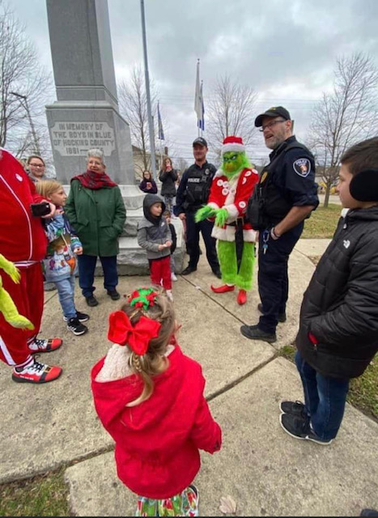

LPD MOUNTED POLICE PROGRAM:

Established in 2019, by Patrolman John Sharp, the mounted unit worked the Veterans and Christmas parades as well as several Athens events in support of the Athens Police Department. The unit has established itself as a popular community relations tool as well as an effective crowd control measure.

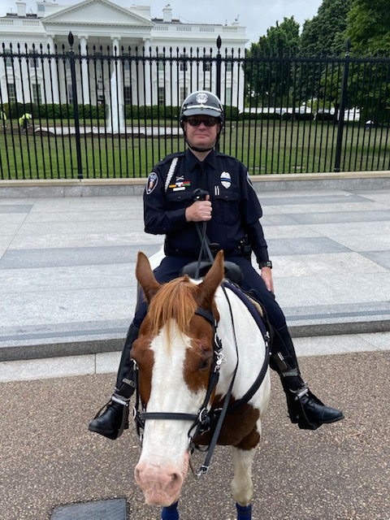

COFFEE WITH A COP:

Coffee with A Cop was launched in Hawthorne, California in 2011 with a focus on finding ways for Law Enforcement to interact more successfully with the citizens they served each day. Community policing has long been considered a framework for establishing trust between the community and the police. However, over time the character and composition of our community has changed due to shifting demographics, more commuters, and the introduction of different communication methods such as websites and social media. Coffee with a Cop events are now held in all 50 states and is one of the most successful community oriented policing programs across the country. The program has also expanded outside of the United States to Canada, Europe, Australia, Africa, and Latin America. The key to Coffee with a Cop’s growing success is that it opens the door for interactions outside of the crisis situations that typically bring law enforcement officers and community members together.

ANNUAL BICYCLE GIVEAWAY:

Annually, the Logan Police Department and Out of the Boat Ministries, restores the many bicycles that have been recovered, impounded, or seized and donates them back to underprivileged members of the community. During this event, members of the community that receive a bike can make a donation that goes towards Shop with a Cop.

DRUG TAKE BACK INITIATIVE:

In 2023 the Police Department teamed up with the Major Crimes Unit for the nationwide annual Drug Take Back Day, where 47.8 pounds of prescription medications were collected. These medications were received and properly disposed of from our community. This program keeps these medications out of our water supply and out of our landfills. In addition, disposing of these drugs properly keeps them out of homes where thefts or misuse of these medications could be a possibility.

SCHOOL RESOURCE OFFICER PROGRAM:

Initiated in early 2000, this is the first major community relations program initiated by the Logan Police Department, and it’s still the most popular and well-known community program in the department. The SRO program has evolved from simply having a patrol officer based at the school for public safety, to a comprehensive program involving elementary, middle school and high school students throughout the school district. The SROs conduct educational programs at the schools that include drug and alcohol prevention, cyberbullying awareness, safe driving, and general health and wellness education to students in the community. The SROs serve as mentors, counselors, and advocates for at risk students in the schools. They provide a positive role model for many kids who lack any structure or positive influence in their homes.

OFFICER PHIL:

The Officer Phil safety program teaches children about stranger danger, the negative effects of bullying, fire safety, and internet safety through fun interactive lesson plans, with the idea of bringing child safety lessons to elementary schools. These programs are continued throughout the year by our School Resource Officers.

2023 GOALS (revisited)

- Attain full staffing levels. (Complete)
- Complete the integration of the fingerprint scanner into the new CAD system. (In Progress)
- Establishment of the CordicoShield Officer Wellness program. (Complete)
- Continue collaboration with Enterprise Fleet Management. (Complete)
- Promote one Officer to the rank of Lieutenant to fill a vacant position due to retirement. (Complete)

2024 GOALS

- Maintain full staffing levels.
- Establish a County wide Officer Wellness program.
- Continue collaboration with Enterprise Fleet Management.
- Add an additional 3 Officers and 1 Lieutenant.
- Send Officers to first line supervisor training.
- Locate funding for new Public Safety Facility.

